### **Metrics and statistics**

Under the Statistics menu, you’ll find a plethora of options to view details about your capture.

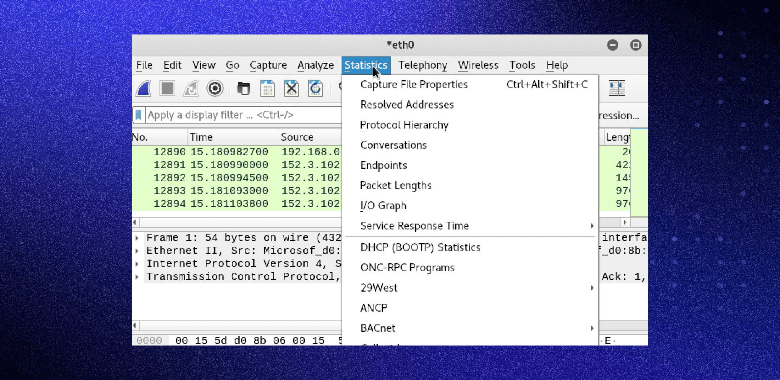

**Capture File Properties**:

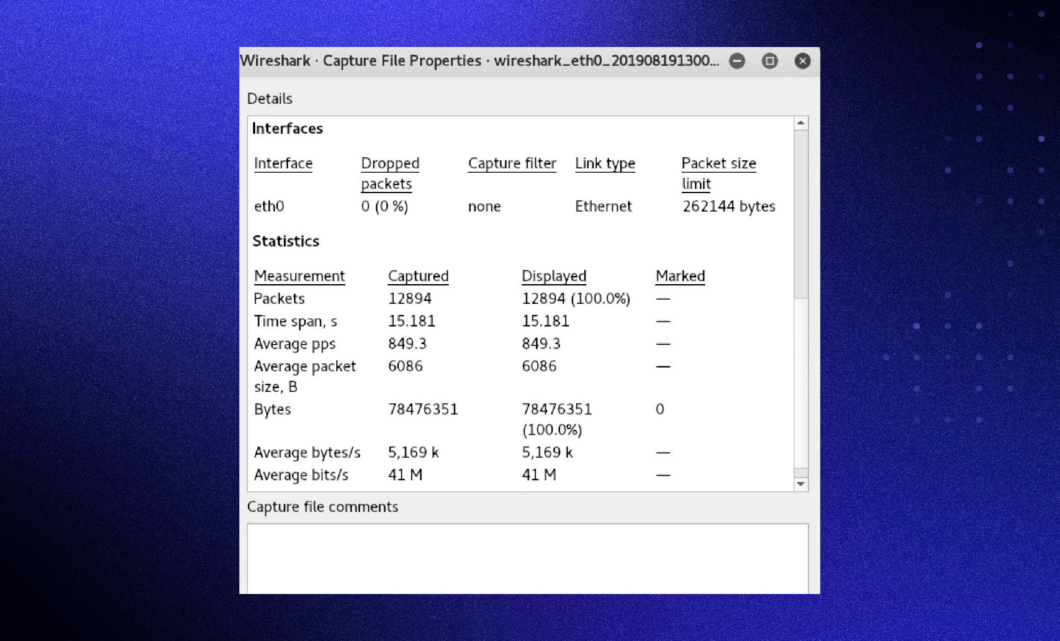

**Wireshark I/O Graph:**

